Gender Equality Diagnostic
(Through HRIS Data Analysis)

Hugo KINGKEOMANIVONG; Keerthana BHASKAR; Shauryaman SINGH
(Year: PGE1 EN, Semester: 1)
A report submitted in partial fulfilment of the Programme Grande Ecole Year 1, Track English
AI Clinic Project with the supervision of:
Professor Anuradha KAR
In collaboration with the enterprise: Alrh Conseil
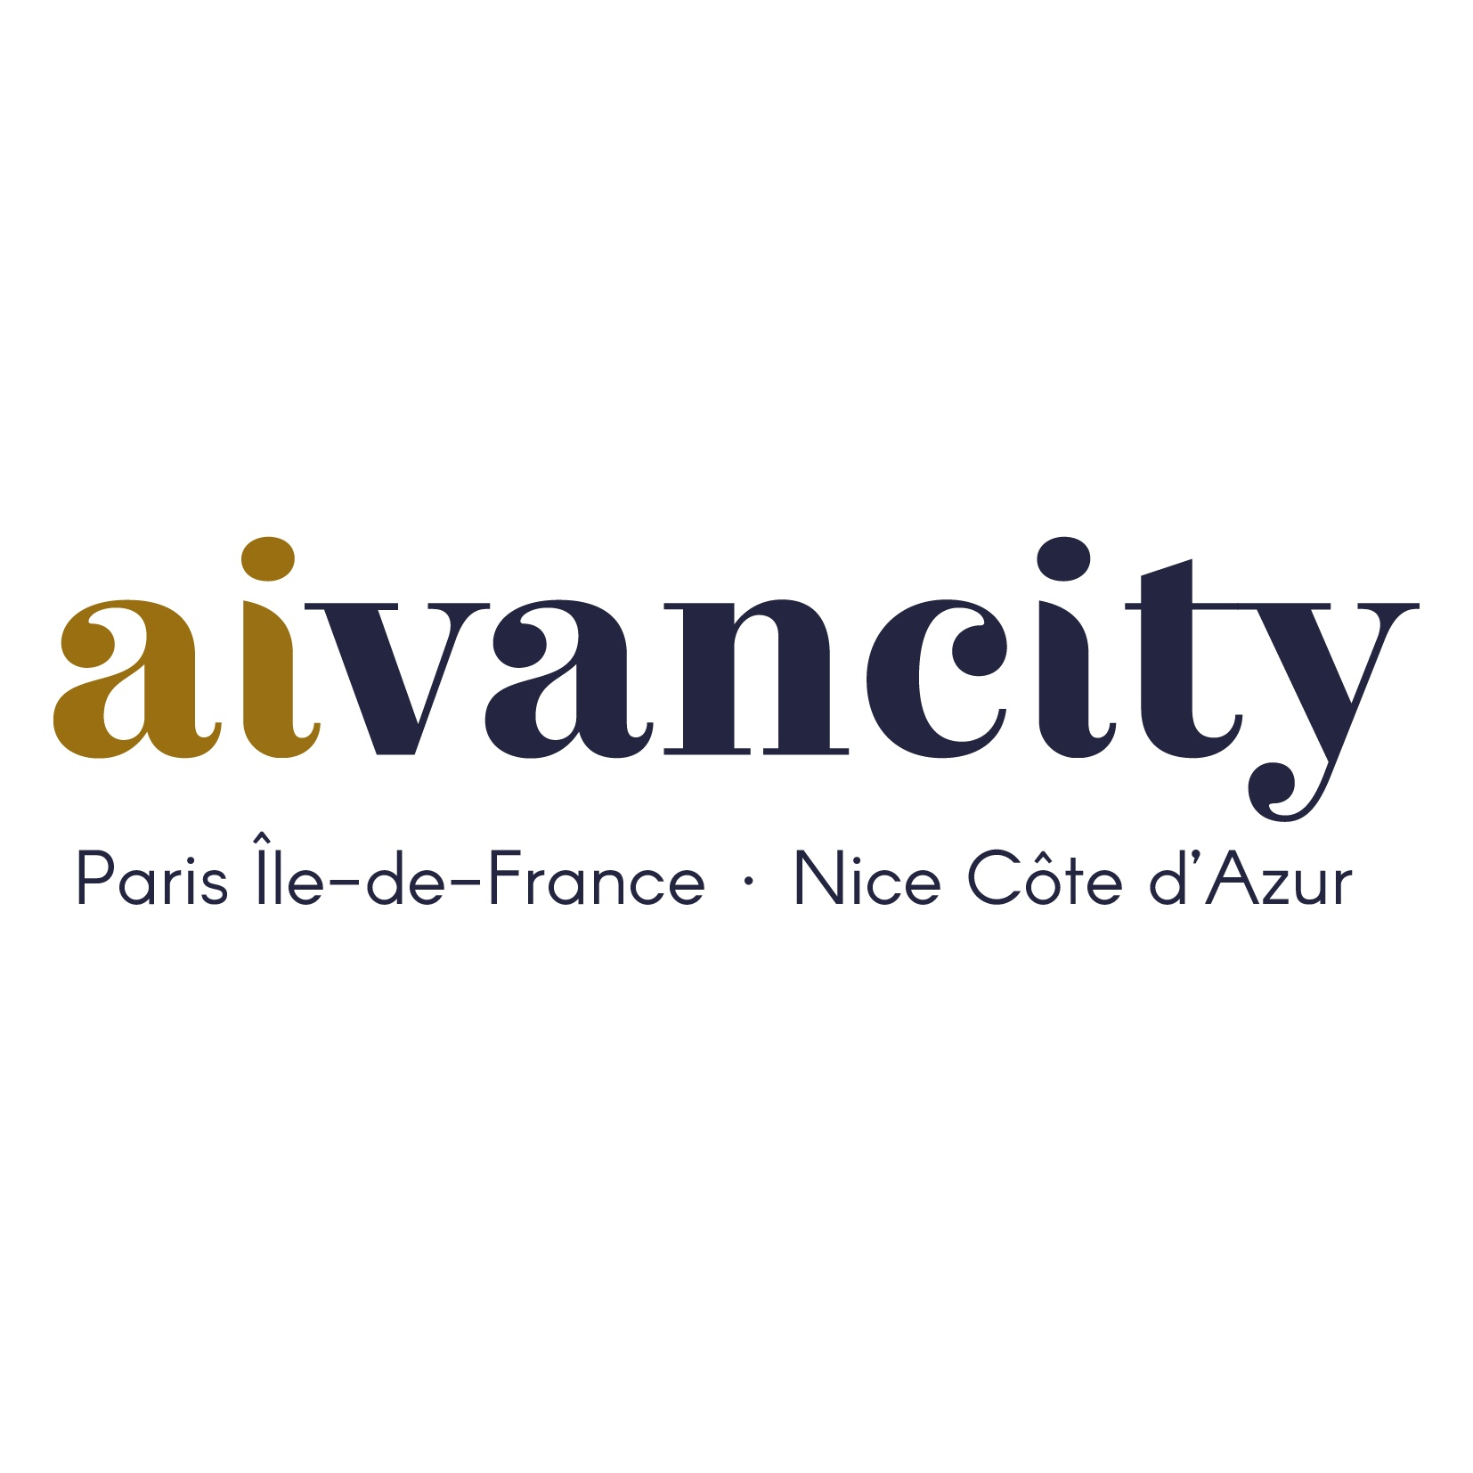
Programme Grande Ecole, Academic Year 2025-2026, Semester 1
Aivancity School for Technology, Business & Society,
Address: 151 Bd Maxime Gorki, 94800 Villejuif
Date: 15/12/2025

Declaration:
We certify that this project is our own work, based on our group study and research and that we have acknowledged all material and sources used in its preparation, whether they be books, articles, reports, lecture notes, and any other kind of document, electronic or personal communication.
We also certify that this project has not previously been submitted for assessment in any academic capacity, and that we have not copied in part or whole or otherwise plagiarized the work of other people. We confirm that we have identified and declared all possible conflicts relevant to this study.
We also certify that this report has not been generated using any generative AI software. Details on the uses of generative AI made for this work are summarized in the next section.

Student 1 signature:
Hugo KINGKEOMANIVONG

Student 2 signature:
Keerthana BHASKAR

Student 3 signature:
Shauryaman SINGH

Declaration on use of generative AI tools:
Which permitted use of generative AI are you acknowledging? | - Text editing  - Grammar refinement  - Clarity improvement  - Translation  - Code commentary and suggestion  - Debugging and documentation
Which generative AI tool did you use (name and version)? | - ChatGPT 5.1  - DeepSeek R1
What prompt did you provide? | - Paragraph restructuration  - Interpretations clarification  - Refining academic tone  - French/English translation  - Code/Dashboard correction  - Graph interpretations optimization.
What did you use the tool for? | - Editing/reorganizing text  - Grammar correction  - Python/Plotly code correction  - Code commentating  - Bugs fix  - Analytical suggestion
How have you used or changed the generative AI’s output? | - We rewrote parts manually, validated all content, and ensured all analysis, results, to remain all project’s results as our own.  - We critically reviewed, tested, and integrated all outputs assistance, wrote all final code/descriptions/interpretation/conclusions ourselves.  - AI tools did not generate the code, computations, or statistical results.

Acknowledgement:

We thank our supervisor, Prof. Anuradha KAR, for guidance throughout the AI Clinic project. We also acknowledge the support of the aivancity academic team. Finally, we recognize the importance of collaborative teamwork within our group, which enabled the successful execution of this data-driven project.

Abstract:
This project delivers a data-driven gender equality diagnostic for the consulting firm AIrhConseil. We applied the CRISP-DM methodology to cleanse and integrate HR datasets using Python, then developed an interactive Streamlit dashboard to analyze disparities.
Our analysis reveals significant structural imbalances and complex trend discrimination.
- A median gender pay gap of 8.7% exists, with extreme department-level disparities ranging from -67% to +56%. Positive values indicating men advantage, negative values indicate women.
- We identify a clear "motherhood penalty" against a "fatherhood bonus" and find pronounced occupational segregation, particularly in R&D and Compta Finances.
- Promotion rates also show gender asymmetry across seniority levels.

These findings enable targeted interventions. We recommend department-specific equity audits, a review of bonus allocation and promotion criteria, and enhanced family-support policies towards women.
The interactive dashboard provides leadership with a transparent tool for ongoing monitoring.
This work demonstrates the application of data science for ethical and juridic HR management, translating employee data into actionable insights for building a more equitable and legal compliant workplace.

Table of Contents
- Introduction
- Dataset
2.1 Key Characteristics
2.2 Data Issues Identified
- Methodology
3.1 Business Understanding
3.2 Data Understanding
3.3 Data Preparation
3.4 Modelling
3.5 Evaluation
3.6 Deployment
- Data Preparation and Cleaning
4.1 Duplicate Removal
4.2 Missing Value Treatment
4.3 Anonymization
4.4 Categorical Normalization
- Indicator Analysis
5.1 Pay Gap by Department and Experience
5.2 Access to Leadership Positions
5.3 Career Progression Patterns
5.4 Parenthood Impact on Careers
5.5 Occupational Segregation Patterns
5.6 Bonus and Variable Pay Distribution
5.7 Overall Salary Distribution
5.8 Part-Time Work and Compensation
5.9 Employee Satisfaction Analysis
5.10 Career Trajectories by Age
- 6. Dashboard (Streamlit)
- 7. Ethical Considerations
- Strategic Recommendations
- Conclusion
- Bibliography
- Appendix

1. Introduction
This project delivers a comprehensive, data-driven diagnostic on gender equality for the consulting firm AIrhConseil. In France, companies are legally mandated to compute and publish an annual gender equality index, making the objective analysis of workplace disparities both a regulatory requirement and a strategic imperative.
Our mission was to leverage AIrhConseil's HRIS datasets to construct a robust analytical framework.
The goal was to move beyond simple compliance reporting and produce a reliable diagnostic capable of identifying specific, actionable disparities in compensation, promotion patterns, occupational segregation, and career progression bias.
This required assessing data quality, developing meaningful metrics, and translating complex findings into clear insights.
To achieve this, the project integrates core competencies in programming, data science, and ethical analysis. We employed the CRISP-DM methodology, utilizing Python for data processing and statistical analysis, and developed an interactive Streamlit dashboard for visualization and exploration.

The final outcome is a functional analytical tool—a dashboard that provides AIrhConseil's leadership with evidence-based insights to inform equitable HR policies and strategic decision-making, thereby strengthening the firm's fair and legal inclusive workplaceiuhuih
2. Dataset
The data originates from the internal HRIS of AIrhConseil and consists of three Excel files:
- Table_Info_pro.xlsx – professional information (departments, positions, seniority).
- Table_remuneration.xlsx – compensation, promotion, variable pay.
- Table_salarie.xlsx – demographic information (gender, civil status, number of children, working time, satisfaction).

2.1 Key Characteristics
- Mixture of categorical and numerical variables.
- Multiple departments: Commercial,Compta/Finance, Consultant, Marketing, R&D, HR.
- Indicators relevant to gender equality: salaries, promotions, bonuses, career length, parenthood information, satisfaction levels.

2.2 Data Issues Identified
- Missing values, especially in promotion and augmentation fields.
- Duplicate employees.
- Non-anonymized personal data (names, phone numbers).
- Heterogeneous department labels and categorical inconsistencies.

3. Methodology

3.1 Business Understanding
The goal is to extract strategic insights for improving gender equality. Key problem questions include:
- Are compensation, promotions, and leadership access equitable?
- Which departments show the largest inequalities?
- How do seniority, age, and parenthood influence outcomes?

3.2 Data Understanding
Initial exploration revealed structural inconsistencies, missing values, duplicates, and sensitive personal identifiers requiring anonymization.

3.3 Data Preparation
Data cleaning was performed using four Python scripts:
- Professional data cleaning: removed duplicates and exported cleaned CSV
(file1_improved.py)
- Salary data cleaning: filled missing numerical values with 0 for calculations
(file2_improved.py)
- Employee data cleaning: removed identifying information, normalized categorical fields
(file3_improved.py)

- Data cleaning launcher: launch the three-cleaning files in one, and permits the adding of an external data file
(main_cleaner.py)

3.4 Modeling
Indicators were constructed and visualized through Streamlit and Plotly. No predictive modeling was used; the focus was descriptive and diagnostic.

3.5 Evaluation
Indicators were compared between genders, departments, and seniority groups to assess fairness. National gender references were used for more accurate evaluation.
3.6 Deployment
A folder downloads from a shared GitHub page, then the terminal launch of Streamlit, will enables the dashboard dynamic exploration of HRIS indicators in your local host.

4. Data Preparation and Cleaning

4.1 Duplicate Removal
Professional data contained redundant entries. Removing duplicates ensured accurate headcounts.
(Handled by file1_improved.py)

4.2 Missing Value Treatment
Promotion and augmentation values were completed with 0, enabling calculations of rates and averages while acknowledging that this may introduce slight biases.
(Handled by file2_improved.py)

4.3 Anonymization
Personal identifiers were dropped to comply with GDPR—names and phone numbers removed.
(Handled by file3_improved.py)

4.4 Categorical Normalization
“Sexe”, “État Civil”, and “Service” fields contained extra spaces and mixed notations. These were cleaned for consistent grouping.

5. Indicator Analysis

Below is the full analysis of each graph, including:
- Indicator description
- Why the difference exists
- Interpretation
- Implications for gender equality

5.1 Pay Gap by Department and Experience
Description:
This graph visualizes the percentage salary gap across departments and seniority intervals (0–3, 4–7, 8–15, 15+ years).
Positive values indicate higher male salaries; negative values indicate higher female salaries.
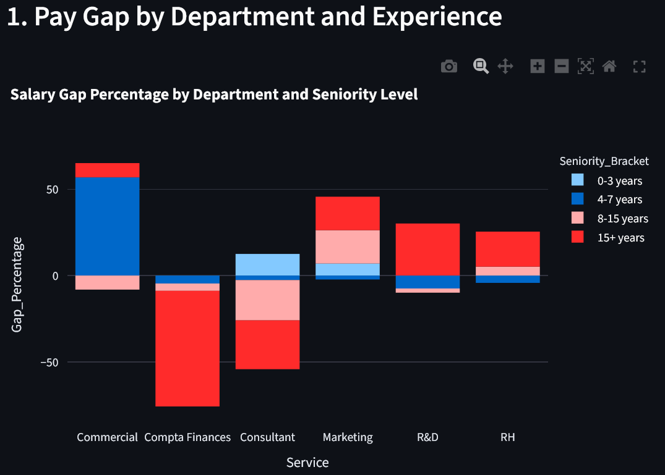
Analysis:
- Gaps vary drastically by department: from –67% (women earn more) to +56% (men earn more).
- Marketing and R&D show strong male advantage, especially in mid-career stages.
- Compta Finances unexpectedly shows a strong female advantage in senior roles.
- Differences arise due to department-specific roles, negotiated salaries, and gender concentration.
Interpretation:
The results reveal department-specific pay practices, not a uniform organizational issue. Some disparities indicate potential structural biases.

5.2 Access to Leadership Positions
Description:
A gender distribution pie chart for leadership-heavy departments shows:
- 54.4% men
- 45.6% women

Analysis:
The slight male overrepresentation aligns with the company's overall gender ratio: 131 men vs. 125 women.
Interpretation:
No strong bias is evident; however, a small advantage appears for men in strategic roles.

5.3 Career Progression Patterns
Description:
Promotion rates compared by gender across seniority brackets.
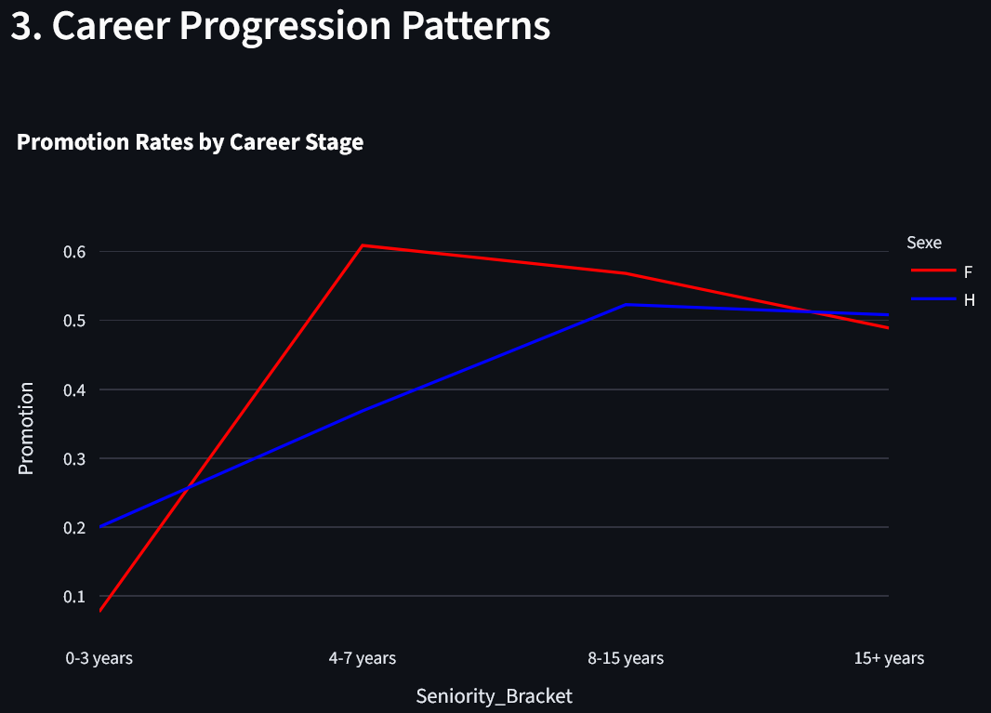
Analysis:
- Men are promoted more frequently early in career (+12%).
- Women surpass men during mid-career (8–15 years), peaking at +30%.
- The gap narrows and the promotion rate decrease at late career stages.
Interpretation:
Promotion criteria may favor men initially but women later—suggesting departmental or managerial differences in progression paths.
We can also remark a lower gap rate of promotions for the the oldest workers, signalling a decrease of promotions for aged workers.

5.4 Parenthood Impact on Careers
Description:
Salary progression plotted against number of children.
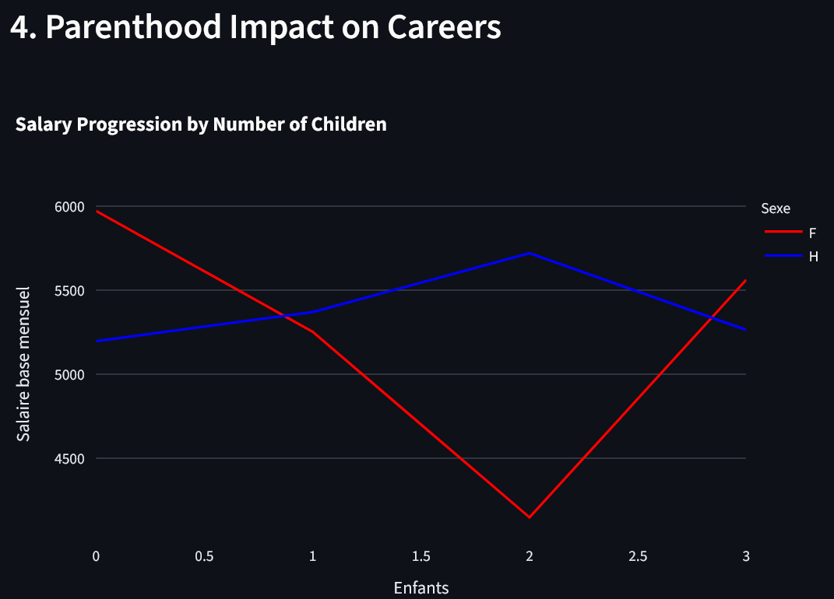
Analysis:
- Women’s salaries drop sharply after having children (–16.5%).
- Men’s salaries increase slightly (+4.9%).
Interpretation:
A classic motherhood penalty and fatherhood bonus. This is a critical red flag, indicating systemic inequity.

5.5 Occupational Segregation Patterns
Description:
Gender concentration (%) by department.
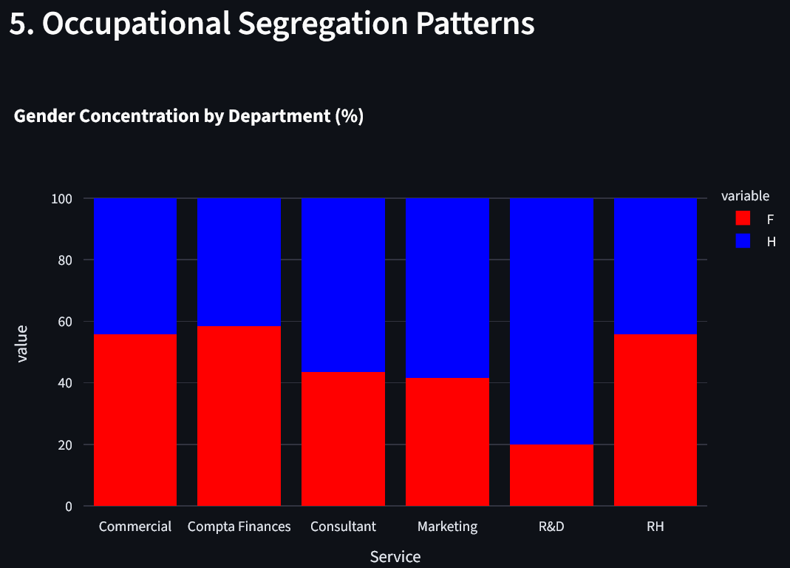
Analysis:
- R&D is 80% male—consistent with national labor statistics.
- Compta/Finance is 58% female.
- Consultant and Marketing are male-dominated.
- RH and Commercial show near parity.
Interpretation:
Segregation likely influences pay gaps and promotion outcomes. Some departments might involve a bias preference towards men, but national records show that few women are disponible on the R&D department nation-wide.

5.6 Bonus and Variable Pay Distribution
Description:
Average variable pays compared by gender.

Analysis:
- Men earn more variable pay in Compta, Marketing, R&D, and Commercial.
- Women earn more in Consultant and HR.
Interpretation:
These analyses show no obvious bias toward a genre and proves complex disparities and not simple beneficiary and victim. Bonus allocation may reflect biased performance evaluation systems.

5.7 Overall Salary Distribution
Description:
Histogram comparing men’s and women’s salary distribution with median markers.
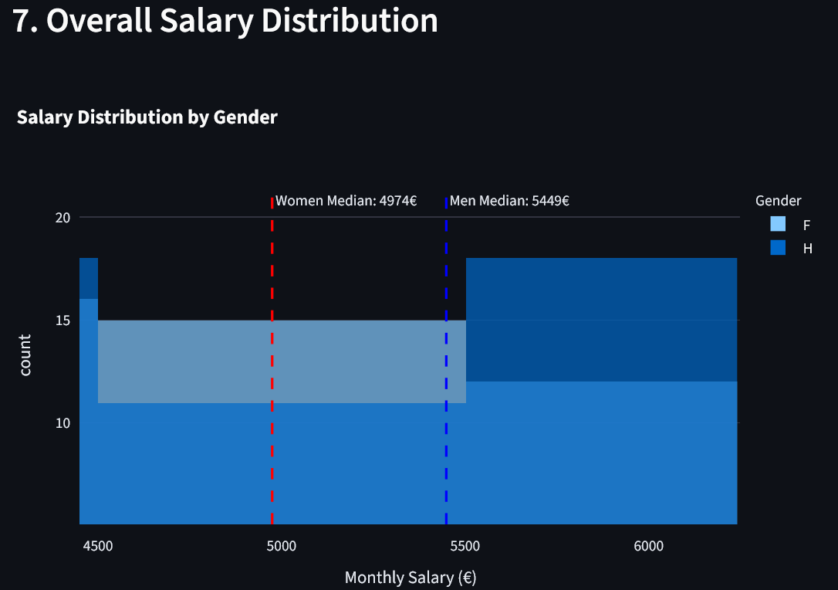
Results:
- Women median salary: 4974 €
- Men median salary: 5449 €
- Gap: ~8.7%
Interpretation:
A general salary gap around 500 € between the two genres can be exposed, it is a clear problem to be corrected.

5.8 Part-Time Work and Compensation
Description:
Boxplot of hourly rates for part-time employees.
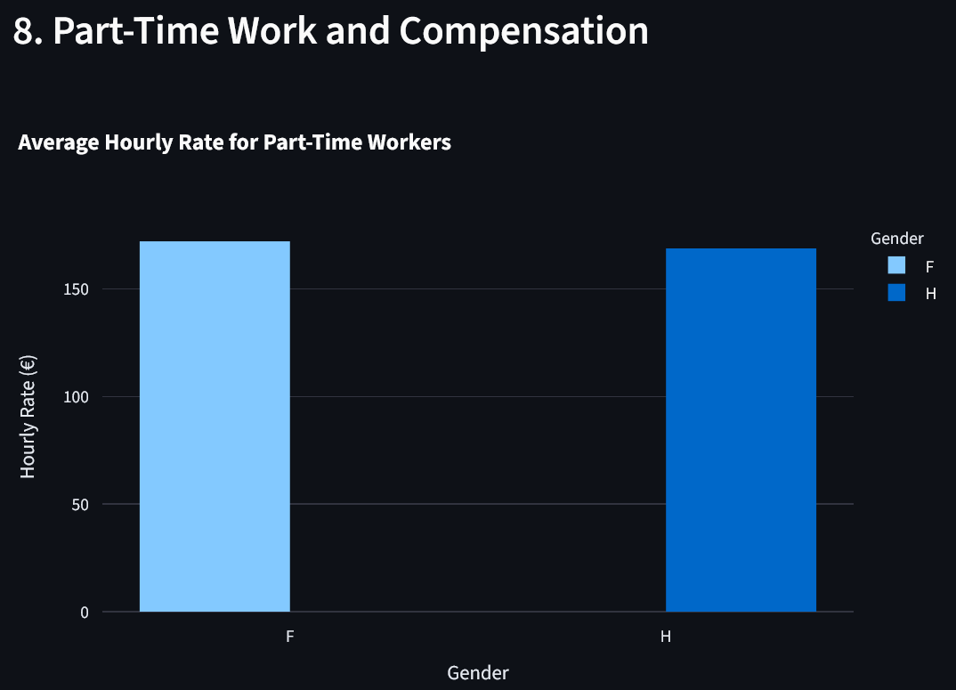
Analysis:
Male rate: 168.88€
Female rate: 172.16€
Interpretation:
Part-time compensation appears relatively equitable, a small advantage is given to female part-time workers.

5.9 Employee Satisfaction Analysis
Description:
Scatter plot of salary vs. satisfaction by gender.
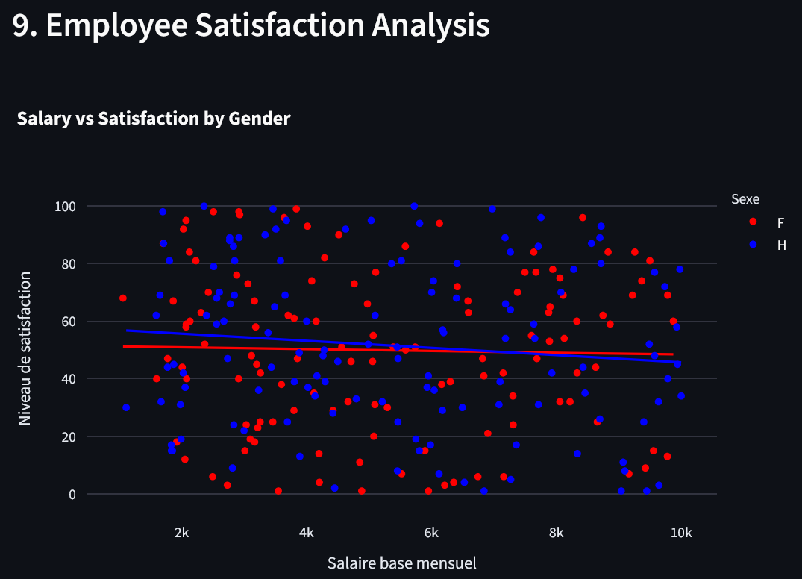
Analysis:
No strong correlation; wide variability suggests salary alone does not determine satisfaction level; there is no clear trend between men or women either.

5.10 Career Trajectories by Age
Description:
Salary by age groups.
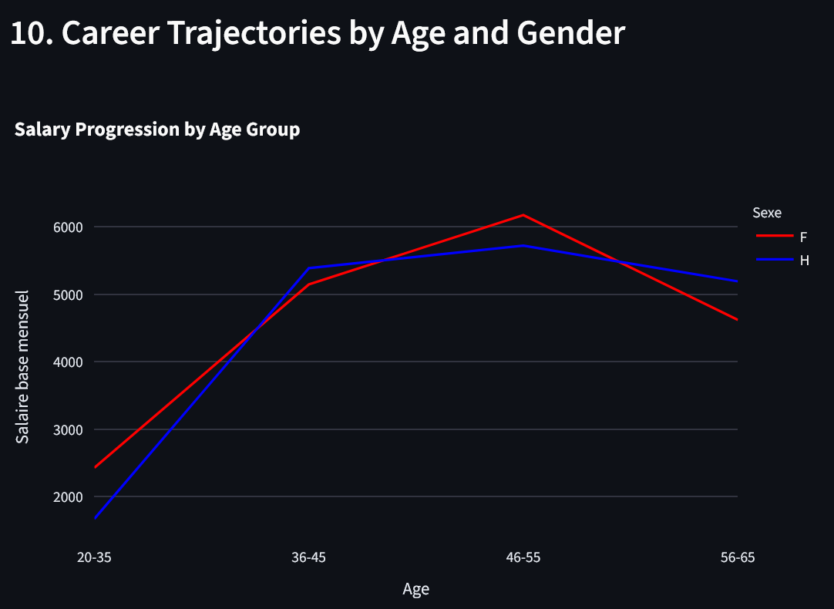
Analysis:
An early salary gap around 600€ is in favour of women for 20–30-year-olds workers,
Around 200€ salary gap in favour of men for 32–40-year-olds workers,
Then a second major salary gap in favour of women around 42-54 for an average of 400€.
Strong decrease of salary level for both genres to the most aged workers.
Interpretation:
Depending on age range, women and men are valorised of better salary progression. But the alarming decrease of salary for elder workers demonstrates a clear seniority discrimination.

6. Dashboard (Streamlit)
Our Streamlit dashboard includes:
- Interactive filters
- Real-time Plotly visualizations
- Department comparisons
- Interpretation panels
- A user-friendly HR interface
It demonstrates a strong integration of data engineering, analytics, and visualization skills.

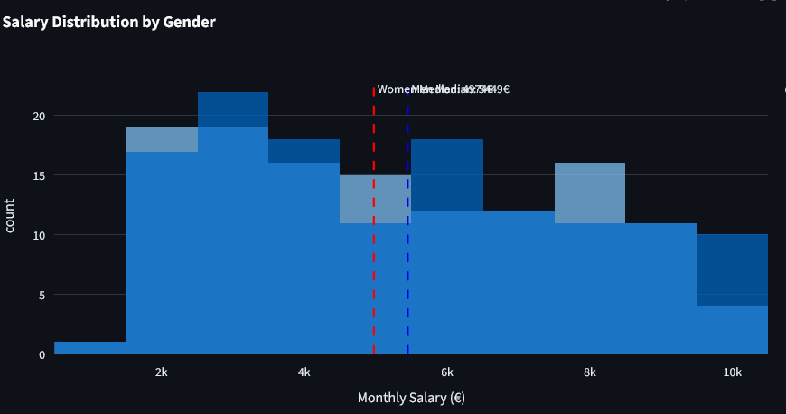
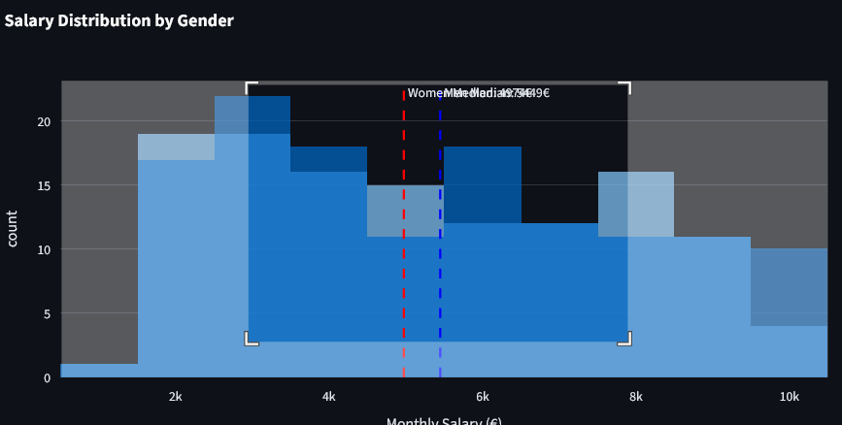
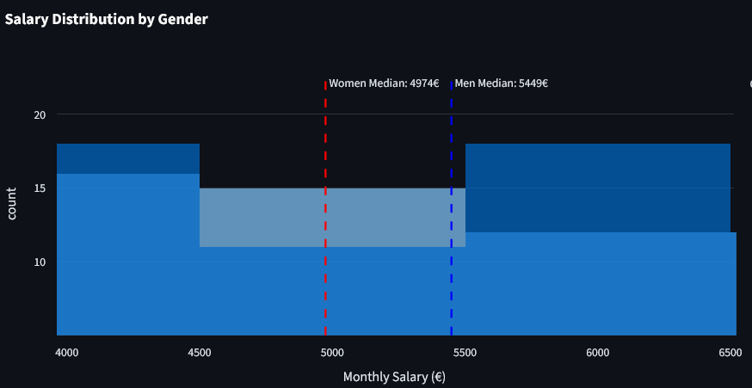

Screenshots of streamlit localhost:

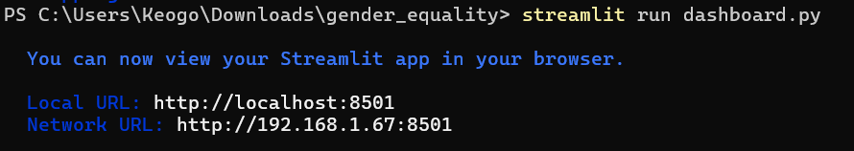
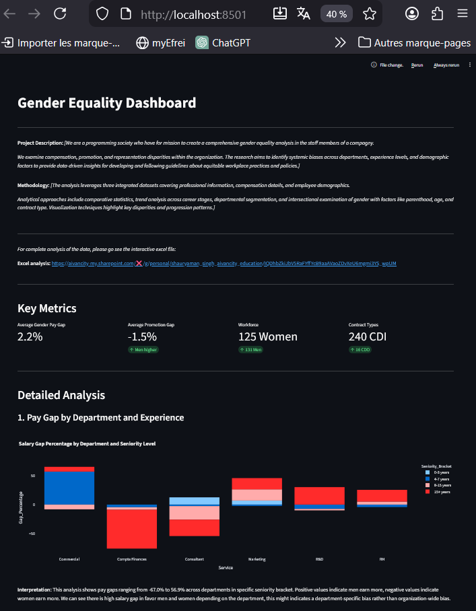

7. Ethical Considerations
The analysis of Human Resources Information System (HRIS) data for gender equality diagnostics requires a careful balance between analytical rigor, ethical responsibility, and strategic relevance. This section outlines the ethical principles that guided the project and presents strategic recommendations derived from the analytical findings, ensuring that insights are used responsibly and constructively.

1. Data Privacy and GDPR Compliance
- Given the sensitive nature of employee data, strict compliance with the General Data Protection Regulation (GDPR) was a fundamental requirement throughout the project. All personally identifiable information, such as employee names and telephone numbers, was removed during the data preparation phase. The analysis was conducted exclusively on anonymized and aggregated data to prevent any form of direct or indirect individual identification.
- Furthermore, the scope of data usage was limited strictly to the objectives of the gender equality diagnostic. This approach respects the principles of data minimization and purpose limitation, ensuring that employee information is not misused or retained beyond its intended analytical purpose.

2. Bias Awareness and Responsible Analysis
- Gender equality analytics carries an inherent risk of reinforcing stereotypes or producing biased interpretations. To mitigate this risk, the analysis avoids attributing observed disparities to individual behavior or gender-based assumptions. Instead, all differences identified in compensation, promotion rates, or representation are interpreted as potential outcomes of organizational structures, historical practices, or systemic processes.
- Special care was taken when handling missing values and uneven departmental representation. Methodological limitations were explicitly acknowledged to avoid overgeneralization and ensure that conclusions remain balanced and context-aware.

3. Transparency and Methodological Integrity
- Transparency is essential when data-driven insights inform strategic HR decisions. All methodological choices, including data cleaning steps, assumptions, and indicator construction, were fully documented. Python scripts used for data preparation were structured to be reproducible and auditable, enabling stakeholders to understand and verify the analytical process.
- This transparency enhances trust in the results and supports informed decision-making rather than blind reliance on automated outputs.

4. Ethical Communication of Results

The communication of findings was approached with caution and professionalism. Results are presented as indicators of potential risk or opportunity rather than definitive proof of discrimination. The analysis focuses on collective patterns and structural dynamics rather than individual cases, ensuring that insights contribute positively to organizational learning and improvement.

8. Strategic Recommendations
The following clear and actionable steps are recommended:
- Fix the biggest pay gaps first.
Conduct immediate, in-depth salary reviews in the Marketing, R&D, and Commercial departments to conduct a direct review with the concerned workers and correct the most extreme disparities depending on the situation.

- Make pay and promotion rules clear and fair.
Create transparent company-wide guidelines for how salaries are set and promotions are earned to reduce hidden bias, a clear table of salary for example.

- Keep careers on track after parental leave.
Introduce a formal program with coaching and guaranteed project access to help parents, especially mothers, return without career penalty, legal and ethical problem to be resolve.

- Build a more balanced talent pipeline.
Actively mentor and attract more women into R&D and more men into Compta/Finance to break down departmental gender divides, an advertisement program should be implemented.

- Launch a "Department Equity Scorecard".
This original measure goes beyond company-wide averages. Each department head would be accountable for a simple quarterly score tracking their team's pay gap, promotion rate gap, and gender balance.
This makes managers directly responsible for equity, turning data into local, actionable goals and fostering healthy competition to improve.

- Clean and standardize your employee data.
Implement strict rules for how data is mandatory entered into the HR system to ensure future reports are accurate and trustworthy for future survey.

10. Bibliography
- Ministry of Labour, France - Professional Equality Index
https://travail-emploi.gouv.fr/ (French source)
- European Institute for Gender Equality (EIGE)
https://eige.europa.eu/gender-equality-index
- Plotly Python Graphing Library
https://plotly.com/python/
Streamlit Documentation
https://docs.streamlit.io/
- Pandas Documentation
https://pandas.pydata.org/docs/

11.Appendix
- Github link of the project:
https://github.com/Keogo811/gender_equality

- For complete analysis of the data, please go see the interactive excel file:
https://aivancity-my.sharepoint.com/:x:/g/personal/shauryaman_singh_aivancity_education/IQDhbZkiJbV5RaFYffYcB9aaAVaoZDvXeU6mgmi3YS_wpUM

